Alexa Jaenicke
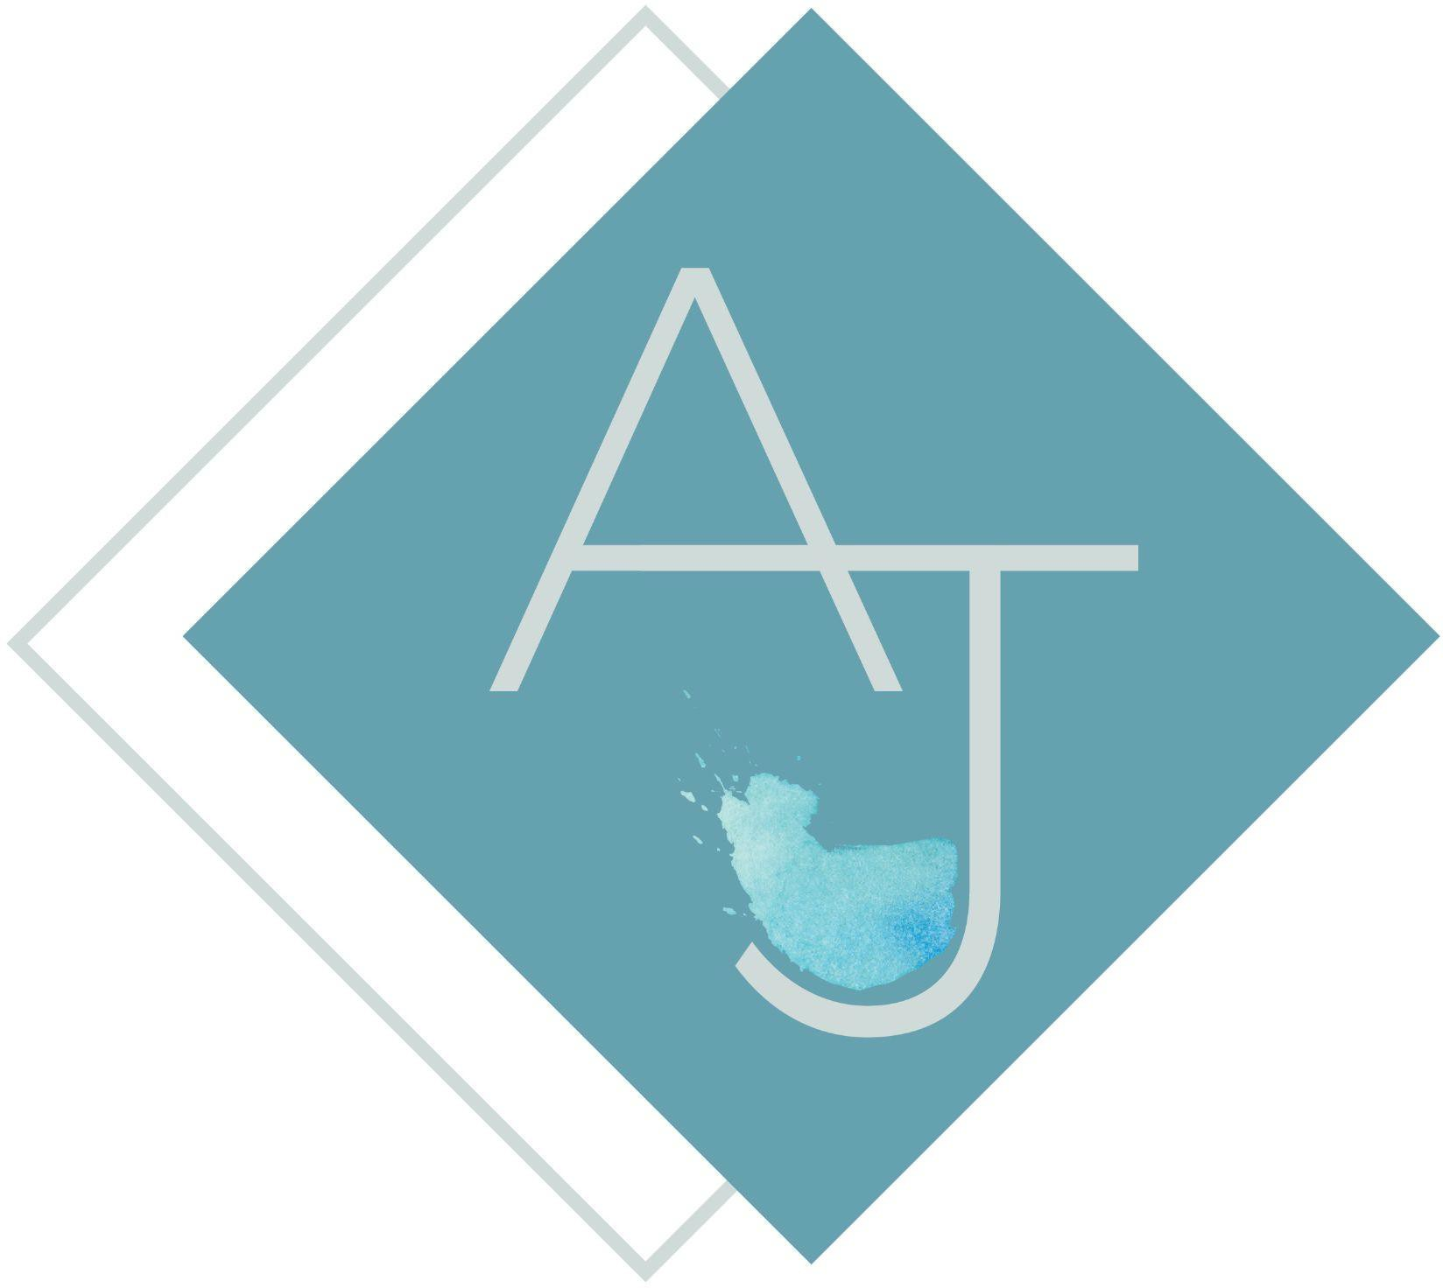

EXPERIENCE

Eunoia, Washington DC — Beverage Consultant
September 2025- Present
- 4 month contract to set up opening wine program and systems
- Curated an accessible wine bottle and by the glass list to match the Mediterranean style business rooted in influences from Mexico City.
- Created inventory systems, training materials, private event programing, and service standards

Reverie, Washington DC — Sommelier
April 2025- September 2025 (Closure Oct 4th 2025)
- Executed wine service at the Michelin level
- Work with the chef team to execute proper pairings for a 11 course menu
- In depth knowledge of specialty food products from Spain, Japan, Italy, and Korea
- Aided in curating the wine and spirits bottle list

Prestige Ledroit Distributing Company, — Wine & Spirits Specialist
Dec 2022- August 2025
- 150 account territory within Washington DC
- Assist creating wine by glass and cocktail menus with products in the portfolio
- Curating pairings with sommeliers for their respective restaurants
- Growing sales of wine and spirits in the territory by 35% over 2023
- Aiding with wine education for account employees and within the company
- Hosting consumer events for suppliers and improving presence in the market
- Overall improving the quality of wine and spirits being represented in the city

Apéro, Washington DC — General Manager, Sommelier
2020- Dec 2022
- Realized the concept of a Sommelier-owned and driven champagne and caviar bar
- Designed the website for Apéro, including colors, design, layout, and flow, managed social media accounts, and engaged in consumer outreach
- Created the private events platform leading to partnerships with Bollinger, Charles Heidsieck, LVMH, and Champagne Bureau of USA
- Built relationships with domestic and international winemakers and importers resulting in exclusive placements
- Hired and trained all employees and developed training manuals
- Managed restaurant budget, including labor, beverage, and tax preparation
- Created a unique spirits menu focused on Armagnac, Mezcal and other terroir driven spirits, complementing the wine collection

RPM Italian, Washington DC — Sommelier
2018- 2021
- Maintained a 3,000-bottle list and two cellars with bi-monthly inventory
- Developed the BTG program and grew relationships with distributors and importers
- Offered private selections to our top spending guests
- Partnered with our private events team to select wines and specialty cocktails for client parties
- Increased wine sales by over 20% on non-typical sale days

+1 (781) - 733 - 2923
amjaenicke@gmail.com alexajaenicke.com
EDUCATION

The Institute of Masters of Wine
Stage One Student

Wine and Spirits Education Trust— Diploma

The Court of Master Sommeliers, — Certiﬁed

The George Washington University, Washington DC — Bachelors in Arts Magna Cum Laude
2016

AFFLIATIONS:

Vin Vitalité
Women in Wine Non-Profit of DC
Membership Chair

SKILLS
Wine and Spirit Education Public Speaking
Adobe Programs

LANGUAGES

Proﬁciency in French Beginner in Spanish

